**Saint Brigid St. John the Baptist**

28th Sunday in

Ordinary Time

October 14, 2018

**Catholic Church Catholic Church**

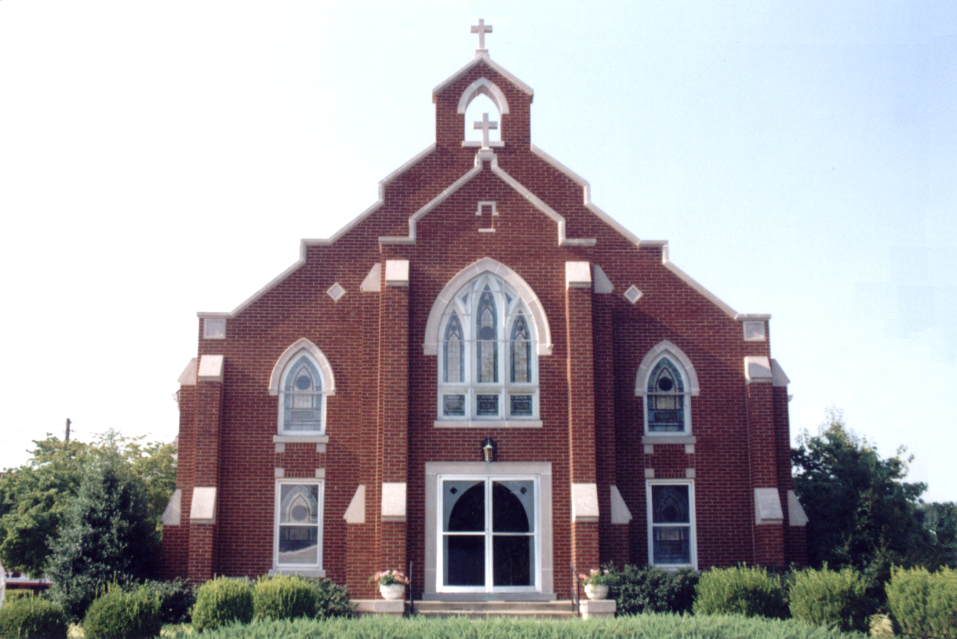

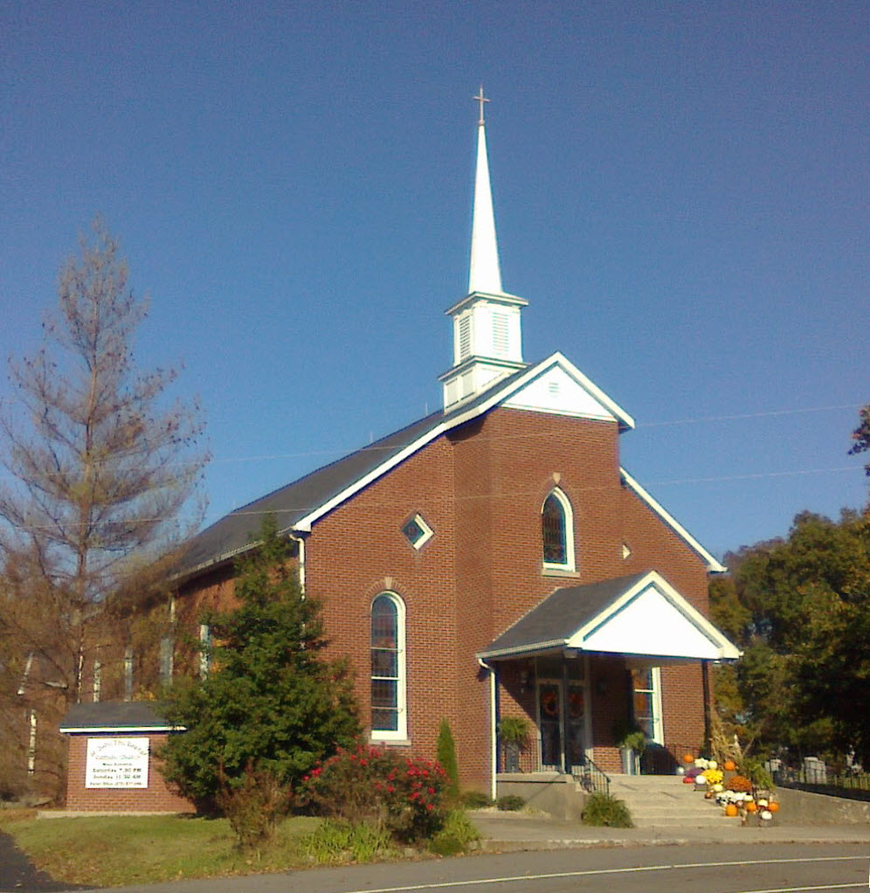

**Pastor:**

***Rev. Daniel L. Lincoln***

Rectory: (270) 877-2546

**Deacon:**

***Michael A. Ryan***

(270) 272-6789

314 E. Main St. 657 St. John Church Rd.

Vine Grove, KY 40175 Elizabethtown, KY 42701

Clustered Parish Office: Clustered Parish Office:

**ANNOINTING OF THE SICK:**

Notify the parish office when a family member is hospitalized.

**BAPTISM:**

Contact the parish office for information about the required preparation class.

**BULLETIN:**

Information must be submitted in writing by note or email to the parish office **no later than 12:00 noon on Wednesdays** for the following weekend. When sending an email, please put “BULLETIN,” and the name of the parish the announcement is for, in the subject line.

**MARRIAGE:**

Contact Father at least 6 months prior to the wedding date to complete required marriage preparations and to schedule the date.

**RCIA (Rite of Christian Initiation of Adults):**

Contact the Worship Chairperson for information.

**DEW MEMORIAL LIBRARY:**

(in St. Brigid Church basement):

Open: Sunday after 9:30 a.m. Mass& 45 minutes before all other Masses.

(270) 877-2461 (270) 877-2461

Email: [brigidvg@bbtel.com](mailto:brigidvg@bbtel.com) **Dir. of Religious Education:**

Website: [www.stbrigidvg.org](http://www.stbrigidvg.org)Lisa Thomas: (270) 735-6930

**Pastoral Associate & Dir. Youth Ministers:**

**of Religious Education:** Angela Churchman:

Deacon Mike Ryan: (270) 877-0546 (270) 268-9963

**Youth Minister:** Ericka Finlay: (502) 612-2644

Lori Law: (270) 723-0157

**MASS SCHEDULE:**

*Saturday (Vigil):*  6:30 p.m.

*Sunday:* 11:30 a.m.

*Wednesday:* 6:30 p.m.

*Friday:* 9:00 a.m.

**RECONCILIATION:**

Saturday before Mass

5:30-6:00p.m. or by appt.

**PARISH COUNCIL MEMBERS:**

*President:* Lauran Thomas

*Secretary:* Theresa Smith

**CHAIRPERSONS:**

*Administration:*  Nick Thomas

*Formation:* Ericka Finlay

*Parish Life:* Bradley Wickersham

*Worship:* Greg Thompson



**MASS SCHEDULE:**

*Sunday:* 9:30 a.m. & 6:30 p.m.

*Monday:* 9:00 a.m.

*Thursday:* 9:00 a.m.

**RECONCILIATION:**

Sunday before Mass

5:30-6:00 p.m. or by appt.

**ROSARY:**

After weekday Masses

**PARISH COUNCIL MEMBERS:**

*President:* Sue Weisshaupt

*Vice-President:* Mike Bramlett

*Secretary:* Judy Cochran

*At-Large Members:* Blake Ryan

& Vincent Thompson

**CHAIRPERSONS:**

*Administration:* Dale Winchester

*Formation:* Tina Yates

*Parish Life:* Tom Billings

*Worship:* Keith Baughman



|  |  |  |  |  |  |
| --- | --- | --- | --- | --- | --- |
| **Saturday** | **October 13** | **6:30 p.m.** | **St. John** | **For All Parishioners** | **Vigil: 28th Sunday in Ordinary Time** |
| **Sunday** | **October 14** | **9:30 a.m.** | **St. Brigid** | **Helen C. Adams**  **Rose Marie Yates** | **28th Sunday in Ordinary Time** |
| **“** | **“** | **11:30 a.m.** | **St. John** | **Eric Yates** | **“** |
| **“** | **“** | **6:30 p.m.** | **St. Brigid** | **Our Parish Family**  **Sandi Crutcher** | **“** |
| **Monday** | **October 15** | **9:00 a.m.** | **St. Brigid** | **Dickie Cecil**  **Martha Ford** | **St. Teresa of Jesus, Virgin**  **& Doctor if the Church** |
| **Wednesday** | **October 17** | **6:30 p.m.** | **St. John** | **Fr. Stan Osborne** | **St. Ignatius of Antioch,**  **Bishop & Martyr** |
| **Thursday** | **October 18** | **9:00 a.m.** | **St. Brigid** | **Inge Luther, Cameron Ponder**  **& Luise Weisshaupt** | **St. Luke, Evangelist** |
| **Friday** | **October 19** | **9:00 a.m.** | **St. John** | **CANCELLED** | **Sts. John de Brebeuf & Isaac Jogues,**  **Priests & Companions, Martyrs** |
| **Saturday** | **October 20** | **6:30 p.m.** | **St. John** | **For All Parishioners** | **Vigil: 29th Sunday in Ordinary Time** |
| **Sunday** | **October 21** | **9:30 a.m.** | **St. Brigid** | **Mack, Leanna & Billy Cecil** | **29th Sunday in Ordinary Time** |
| **“** | **“** | **11:30 a.m.** | **St. John** | **Bruce & Margaret Lincoln** | **“** |
| **“** | “ | **6:30 p.m.** | **St. Brigid** | **Our Parish Family**  **Hellen C. Adams** | **“** |

**For Both Parishes**

**FR. DAN WILL BE AWAY** – on retreat at St. Meinrad from **Tuesday, October 16 until Friday, October 19.**

**HURRICANE FLORENCE** – with its related rain and flooding has caused massive destruction in North and South Carolina, and other weather events will likely cause destruction in the United States and elsewhere in the remaining months of the year. We can assist our brothers and sisters affected by disasters in 2018 through monetary donations that will be used to support the efforts of Catholic Charities and/or Catholic Relief Services as they provide emergency assistance to those in need. Funds also will be directed to pastoral and reconstruction needs of the Church should they arise. Checks should include the notation: 2018 Disasters and can be turned into the parish or sent to Catholic Charities of Louisville, 2911 S. 4th Street, Louisville, KY 40208-1303.

**VOCATIONS** – Do you know a young man or woman who might make a great priest, brother or sister? Help the Archdiocese of Louisville Vocations Office connect with them! By submitting names through our Called by Name initiative, you'll help us send potential discerners good information and invitations to discernment events. To participate visit: [www.louisvillevocations.com/called-by-name/](http://www.louisvillevocations.com/called-by-name/)

**ABORTION AND ADOPTION –** The number of would-be adoptive parents (of newborn babies) far outstrips the supply in America. Each year in the United States, about 135,000 American children are placed for adoption. Experts estimate somewhere between one and two million couples seek to adopt yearly. Every year, there are about 1.3 million abortions. Sadly, only 4% of women with unwanted pregnancies give their children up for adoption. Every child is wanted and wanted desperately! By Pro-Life Articles Author [www.pro-lifearticles.org](http://www.pro-lifearticles.org)

**PROJECT RACHEL** **–** Healing…Forgiveness…Hope…After the experience of an abortion. If you or someone you know is struggling with the pain from an abortion, please consider Project Rachel – a post abortion ministry. To speak to someone confidentially, call (502) 471-2155 or email [ProjectRachel@archlou.org](mailto:ProjectRachel@archlou.org).

**CONFIDENTIAL PREGNANCY AND ADOPTION COUNSELING** – is available at Catholic Charities for women of all ages experiencing untimely pregnancies. A full range of services are provided, including adoptive placement, legal assistance and counseling for individuals, groups and families. Post-abortion counseling is also available. Services are provided regardless of income or marital status. For more information, call Catholic Charities at (502) 637-9786.

**WEDDING ANNIVERSARY MASS** – Archbishop Joseph Kurtz warmly invites couples celebrating their 30, 40, 50, 60 & 60 plus years wedding anniversary in 2018 to join others in the Archdiocese for a Mass of Thanksgiving at the Cathedral of the Assumption, 433 S. Fifth Street, Louisville, on **Sunday, October 21, at 2:00 p.m.** Family members are also invited to the celebration. Each couple will receive a certificate commemorating the occasion. Registration is required. Call the parish office to **register before Friday, October 5.**

**THE ST. MARTIN’S ARCHIVE COMMITTEE FUNDRAISER** – The Monarchs will perform in the St. Marin Gum on **Saturday, November 3, from 7:00-10:00 p.m.**  Because we have several very generous sponsors we are able to accept $15 donation to attend. This money will be use for the renovations and upkeep of the archives. For anyone who not familiar, the Monarchs, from Louisville, played music from the 50’s, 60’s and 70’s. There will be something for everyone if you want to dance or just listen. Our “theme” is Senior Prom,” Junior of you’re under 70!! Dress the way you want for the prom – casual, formal or somewhere in between. If you loved your prom – relive it. If you did not love your prom – remake it. If you never had a prom – here is your chance. The Locals food truck will be at the gym from 6:00-8:00 p.m. or as long as they are busy. You may bring snacks and drinks. **No Alcohol please**. Everyone is welcome.

**St. John and St. Brigid Prayer List**

To add someone to the prayer list, please call the parish office at (270) 877-2461. **Remember to call to remove someone from the list if they are no longer sick, etc.** *Please note that the prayer list has been revised. It is primarily for parishioners and their immediate family members*.

Leslie **Adams-Cerniglia**, Sam **Adams**, April **Allen**, Dennis **Arnold**, Barbara **Ashley**, Donnie Alan **Atcher**, Sue **Banks**, Shannon **Barnes,** Denise **Barnett**, Timothy **Birch**, Teresa **Blaycock**, Charlie **Bowers**, Pauline **Brangers**, Ellen **Bryan**, Richard **Bryson**, Carol **Buchanan**, Linda **Buchanan**, Jeremy & Margie **Buyer**, Deacon Bob **Caspar**, Sue **Caswell**, Ed **Cecil**, J. Mack **Cecil**, Steve **Cecil**, Harlan Ford **Clark**, Judy **Cleaver**, John **Connor**, Betty Jo **Cooper**, Heidi **Correa**, Jeff **Craig**, Glynn **Clutches**, Roan **Dowell**, Karen **Dworshak**, Leroy **Embry**, Marion **French**, Martha **Ford**, Dwayne **Garcia**, Carrie **Gribben**, Mary **Hager**, Mrs. Charles **Hair**, Stephanie **Hall**, Donnie **Hart**, Jimmy **Harper**, Bobby **Harris**, Eileen **Heinen**, Debbie **Hodge**, Betty Lou **Jones**, Charlene **Langley**, Olivia **Leasor**, Jenny **Leonhardt**, Jackie **Long**, Louise **Lucous**, Alma **Mahanna**, Shelly **Martin**, Shirley **Martin**, Martina **Masoni**, Don **Mattingly**, Gerard **Mattingly**, Paul Michael **Mattingly**, Mary **Medley,** Cindy **Miller**, Starla **Miller**, Doug **Osborne**, Duane **Osborne**, Mickey **Padgett**, Frank **Inanely**, Jerry **Phillips**, Annie **Pierce**, Adrianna **Porter**, Jeremy **Porter**, Adrian **Ray**, Allie **Ray**, Mary Agnes **Ray**, Mary Ellen **Ray**, Tonya **Reisinger**, Joel **Rivera**, Caroline **Seabee**, Leon **Skeeters**, Jim **Smith**, Ralph **Staples**, Keith **Tassin**, Anthony **Thomas**, Kenny **Thompson**, Raffaella **Tucker**, Debi **Turner**, Stacey **Vance**, Bill **Waldrop**, Lois **Weaver**, De Neil **Whelan**, Paul A. **Whelan**, Jennifer **Williams**, Sandy **Wiseman**, Zach **Wiseman**, Gail **Wilson**, Don **Wooldridge**, Connor **Wright**, and all the sick, both mentally and physically.

**OUR MILITARY List**

To add someone to the military list, please call the parish office at (270) 877-2461. **Remember to call to remove someone from the list if they are no longer in the service**.

Lt. Matt **Bednar**, PFC Richard H. **Chapman**, A1C Aaron **Chandler**, A1C Brandon **Davila**, SrA Felicia **Esquivel**, PFC Tyler **Hall**, A1C Ryan **Henley**, A1C Joseph **Manco**, SPC Jacob L. **Nall**, SFC Peter **Novak**, Tony **Rickerl**, James **Rogers**, Tony **Rogers**, Jonathon **Sifford**, Jeffrey **Slade**, Derek **Smith**, CSM Vance **Snider**, Brian **Tomassi**, A1C Daniel **Trombone**, SGT Evan **Vaughan**, PV2 William **Vaughan**, Lisa **Flynn-Veri**, LT Michael **Veri**, LTC Steve **Wickersham**, SGT Clay **Wilson**, TSGT Jeremy **Yates**, Austin **Zulka** and for all who serve and have served our country.

**St. John The Baptist catholic church**

**Monthly Budget Amount Needed:** $ 12,500.00

**Monthly Collection for September:** $ 12,268.00

**Monthly Collection for October:** $ 2,820.00

**WELCOME PACKETS** – If you would like to become a member, or learn more about St. John Parish, please take a *Welcome Packet* in the church lobby. You may return the census card and the stewardship form to Father Dan or place in the collection basket.

**CATHOLIC SERVICES APPEAL 2018** – Our financial goal this year is $21,900. Our participation goal is 96 families. Let us respond promptly and generously this year.

**PRAYERS** – Please keep Gabe Pike and Emily Bohannan in your prayers as they prepare to be married this Saturday at St. John

**MASS CANCELLED – Friday, October 19, Mass at 9:00 a.m. cancelled.**

**DISCERNMENT CORE TEAM UPDATE** – In our continuing effort to develop and follow thru with our Discernment mission we are focusing on the following two groups to meet this month.

**Women’s Group:**  If you signed up for this group during the Stewardship Fair or if you are interested in joining our Ladies Group, we will have two informational and organizational meetings on **Monday, October 15, at 10:00 a.m. and 6:30 p.m.** in the Parish Hall.  We hope to have enough interest to develop a daytime and an evening group to accommodate everyone's schedule.  Come out and join one of these groups as we develop our Women's Ministry.

**Small Group Study:**If you signed up for this group during the Stewardship Fair or if you are interested in joining a small group study, we will have a meeting for this group to discuss their ideas and wishes for Small Group Studies on **Wednesday, October 10, at 6:45 p.m.** immediately following the evening Mass in the Parish Hall

**PARISH COUNCIL** – will meet on **Monday, October 29, at 6:30 p.m.** in the Parish Hall.

**SAFE ENVIRONMENT TRAINING –** St. John will be hosting a Safe Environment Training on **Monday, November 12,** at 6:30 p.m. in the Parish Hall.  This training is required one time only for anyone volunteering with our youth or any other potentially vulnerable individuals.  The training lasts approximately 1 to 1 1/2 hours.  Anyone volunteering with the Religious Education Program or Vacation Bible School must have this training.  No pre-registration is required.  Any questions contact Lisa Thomas (270) 735-6930 or [glalt@comcast.net](mailto:glalt@comcast.net)

**ROOM IN THE INN** – St. John The Baptist will sponsor the Friday nights of **December 28, January 25, and February 22** for this program to help the homeless in our area. Contact Elaine Geer at (270) 763-2202 or (270) 737-4172 to volunteer or for more information.

**St. John liturgical ministers**

|  |  |
| --- | --- |
| **Vigil: 29th Sunday in Ordinary Time, October 20, 2018** | **6:30 p.m.** |
| Extraordinary Ministers of the Eucharist | Becky Thomas Dennis Thomas Angela Churchman |
| Lector | Tony Smith |
| Servers | Drew Thomas Audrey Hunt |
| Greeter(s) | Rhonda Newton |
| Gift Bearers | John & Brenda Thomas |
| - Ushers | John Thomas Zach Thomas |
| **28th Sunday in Ordinary Time, October 21, 2018** | **11:30 a.m.** |
| Extraordinary Ministers of the Eucharist | Libby Brangers Martha Thomas Scott Mattingly |
| Lector | Cindy McLain |
| Servers | Olivia Leasor Rilee Leasor |
| Greeter(s) | Clarissa Yates |
| Gift Bearers | Vicky, Emily & Callie Taylor |
| Ushers | Brandon Wiseman Trent Thomas |
| **Hospital Ministry – Sunday, October 28, 2018** | Martha Thomas & Lauran Thomas |

**St. Brigid catholic church**

**Monthly Budget Amount Needed:** $ 25,280.00

**Monthly Collection for September:** $ 28,895.29

**Monthly Collection for October:** $ 8,973.50

**WELCOME VISITORS** – If you are interested in joining our parish, please pick up a Welcome Packet at the church doors. Complete the registration form and either drop it in the collection basket or mail it to the office. If you just need to update your registration, there are also forms available.

**CATHOLIC SERVICES APPEAL 2018** – Our financial goal this year is $35,500. Our participation goal is 129 families. Let us respond promptly and generously this year.

**THANK YOU!** On behalf of the Myra Cannon family, our wish to express our deepest appreciation to St. Brigid Parish for the wonderful funeral dinner provided for us. A special thanks goes to Keith & Martha Baughman, Nan Filburn, Betty Kieta and Evelyn Russell for served the meal and to all who prepared the food. God bless you all.

**EXTRAORDINARY MINISTERS OF THE EUCHARIST** – October through December 2018 EM schedules may be picked up at the back of the church. Thank you for your continued service.

**ST. VINCENT DE PAUL SOCIETY** – Because of tax law changes all donations to SVDP should be made out to St. Vincent de Paul NOT to St. Brigid Church. Your donation is still tax deductible. THANK YOU for your continued support of SVDP to help the local poor and needy.

**BASKETBALL PROGRAM** – Basketball will not begin until October, so we will post sign-up sheets in August. So far, we have had one adult offer to coach and one adult offer to coach and play in an adult league.

**FROM THE LIBRARY** – **>** There is now an Accelerated Reader section in the library.  Books are labeled by grade level K-8.  Please read and return the book to the correct tub.  Good luck on your testing at school! **>** There is a High School reading section geared toward college bound.  Read and return. **>** Four tables are full of free adult reading.  Read and pass along. **>** The kid table is full of books to be read and returned.  Many new choices. > The large circle table is now a Genealogy resource.  Books need to be checked out and returned. **>** Dr. Dew’s library is still intact.  Read and return where you got them. **>** Thanks to those who have donated books for all to enjoy!

**BLOOD DRIVE** – The next blood drive will be held on **Friday, October 12, from 10:00 a.m. to 2:00 p.m.** in the CCC.

**PARISH COUNCIL** – will meet on **Thursday, October 25, at 7:00 p.m.**

**St. Brigid youth ministry**

**Wednesday, October 17** – Youth Open Gym in the CCC for all 8th-12th graders from 6:30-8:30 p.m. Our new year of youth group is just getting started. If you have never come to open gym or other youth events in the past now is a good time to get started. Join us for games, play ball, socialize or bring something new to the group.

**Saturday, October 27** – **Mark your calendars!** The Fowler Family has opened their home and invited our youth group to a Fall Gathering at 6:00 p.m. All 8th-12th graders are welcome to come out for an evening of fun! More details will be coming in next week’s bulletin and through group text but for now keep the date clear.

If you have any questions, please contact Lori at (270) 723-0157 or email at [stbrigidyouth@hotmail.com](mailto:stbrigidyouth@hotmail.com).

**St. Brigid monthly meet and greet**



St. Brigid Parish hosts a “Meet and Greet” downstairs the 2nd Sunday of each month immediately following the 9:30 a.m. Mass with coffee and donuts. This is a great opportunity for existing parishioners to extend a warm welcome to visitors and anyone interested in joining St. Brigid Parish. Be sure to also visit the Dew Memorial Library.

**The next Meet and Greet will be Sunday, October 14, 2018.**

**St. Brigid liturgical ministers**

|  |  |
| --- | --- |
| **29th Sunday in Ordinary Time, October 21, 2018** | **9:30 a.m.** |
| Extraordinary Ministers of the Eucharist P. | Denise Hester Janey Jenkins |
| C. | Butch & Nan Filburn E. Jane Vessels |
| Lector | Blake Ryan |
| Servers | Maggie Board Cal Yates |
| Greeters |  |
| **29th Sunday in Ordinary Time, October 21, 2018** | **6:30 p.m.** |
| Extraordinary Ministers of the Eucharist P. | Richard Osterhage |
| C. | Donna Osterhage |
| Lector | Richard Osterhage |
| Servers | Jackie Veri |
| Greeters | Volunteers |
| **Hospital Ministry – Sunday, October 14, 2018** | Ralph and Sherleen Barren |

**St. Brigid faith formation news**



**FAITH FORMATION NEWS**

Pack Your Trunks and Get Ready for a Treat!

St. Brigid hosts our Annual Trunk or Treat on **Wednesday, October 31** during Vine Grove’s Trick or Treat hours.

Set-up no later than 5:30 p.m. in the indoor comfort of the CCC. Pick out your spot and go wild with decorations for “your trunk”!! Costumes welcome. No masks please!

Questions? Call Selina Chandler at (270) 765-3672.

**MARRIAGE MOMENTS**

It is natural to want stuff – food, clothing, shelter are necessities. Fashionable clothes, eating out and electronics are not evil. BUT, how do you reconcile these desires with “How hard it is for those who have wealth to enter the kingdom of God?” (Mark 10:23) How much is enough? Decide at least one thing to give away today.

**PARENTING POINTERS**

Children make mistakes. That’s natural. Of course you forgive them. For example, they may promise to never drink and drive again. Believe them. But this doesn’t mean you enable a teen by being blind to reality. Forgive but verify. (Parenting Your Adult Child)